Research Paper for VLSI Project
  - GNN-RE: Graph Neural Networks for Reverse Engineering of Gate-Level Netlists
Link : 1. Online Link
2. Github Repo Link
3. Claude AI chat

Paper Overview and Objective:
This work introduces a generic, machine learning (ML)-based platform for functional reverse engineering (RE) of circuits. Our proposed platform GNN-RE leverages the notion of graph neural networks (GNNs) to: 1) represent and analyze flattened/unstructured gate-level netlists; 2) automatically identify the boundaries between the modules or subcircuits implemented in such netlists; and 3) classify the subcircuits based on their functionalities.
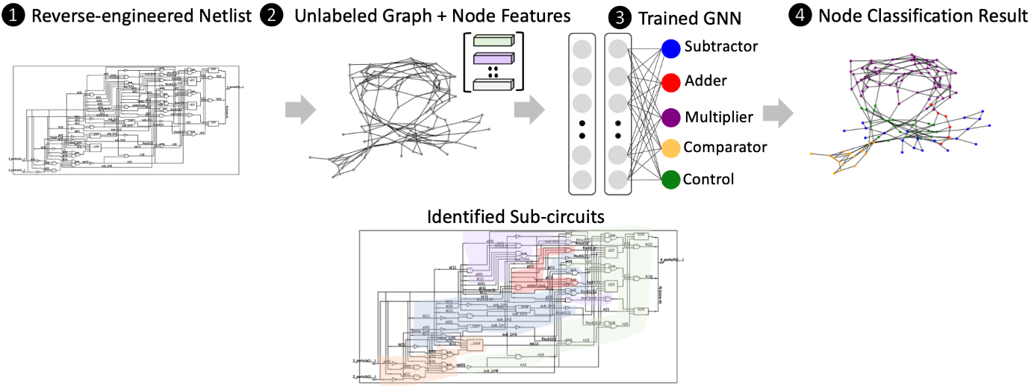

Problem Definition
Traditional Challenge: When circuits are synthesized and flattened, the original hierarchical structure (modules/subcircuits) is lost. Reverse engineering aims to reconstruct this hierarchy from flat gate-level netlists.
Key Tasks:
- Module Boundary Detection: Identify which gates belong to the same functional module
- Subcircuit Classification: Determine the functionality of each identified module (e.g., adder, multiplier, decoder)

GNN-RE: Technical Approach and Mathematical Foundation
1. Graph Representation
- Circuit as Graph: Gates = Nodes, Wires = Edges, creating graph G = (V, E)
- Node Features: Each gate has profile with type (AND/OR/NOT), input count, output count, circuit depth
- Analogy: Circuit like city map where buildings (gates) connected by roads (wires)
2. Graph Neural Network Process
- Information Sharing: Each gate communicates with neighboring gates
- Three-Step Process:
  - Step 1: Gate sends message to neighbors about its properties
  - Step 2: Gate collects all messages from neighbors
  - Step 3: Gate updates its knowledge based on collected information
- Mathematical Formula: New_Info[gate] = Function(Old_Info[gate], Neighbors_Info)
3. Two Main Tasks
Task 1: Module Boundary Detection
- Objective: Identify which gates belong to same functional module
- Question: "Do gate A and gate B work as a team?"
- Output: Binary classification (YES=1, NO=0) for each gate pair
- Formula: P(same_team) = Sigmoid(Combined_info_of_A_and_B)
Task 2: Module Classification
- Objective: Determine functionality of each identified module
- Question: "Is this module an ADDER, MULTIPLIER, or DECODER?"
- Output: Multi-class probability distribution
- Formula: Probabilities sum to 100% across all possible classes
4. Loss Functions (Error Measurement)
- Boundary Detection Loss: Count wrong predictions about gate relationships
- Classification Loss: Count wrong predictions about module types
- Combined Loss: Total_Loss = (0.6 × Boundary_Errors) + (0.4 × Classification_Errors)
- Purpose: Measure model performance and guide learning
5. Training Algorithm
- Step 1: Make predictions on circuit
- Step 2: Compare predictions with correct answers
- Step 3: Calculate total mistakes (loss)
- Step 4: Adjust model parameters to reduce mistakes
- Step 5: Repeat process thousands of times until satisfactory accuracy
6. Key Mathematical Components
- Message Passing: new_info = old_info + neighbor_info
- Aggregation: total_neighbor_info = sum of all neighbor messages
- Update Function: h_new = ReLU(W × [h_old + neighbor_info] + bias)
- Probability Calculation: probability = sigmoid(prediction_score)
- Sigmoid Function: Converts any number to probability between 0 and 1

Implementation Logic:
1. Circuit Netlist → Convert to Graph
2. Graph → Extract Features (gate types, connections)
3. Features → Feed to GNN
4. GNN → Process through multiple layers
5. Final Layer → Make predictions
6. Predictions → Compare with truth, calculate loss
7. Loss → Update model weights
8. Repeat until good enough

MID-TERM EVALUATION

GNN-RE Implementation:
- The implementation is broken into three main phases: Setup, Data Preparation (*), and Training.

- Phase 1: Setup and Tools (Preparing the Environment)
We ensure we have the correct software and dependencies to handle both the old parsing scripts and the modern AI framework.
- Install System Tools: We first install essential system utilities like Perl (a language built for text processing) and C++ compilers. Perl is needed to read the raw circuit files, and C++ is needed to compile the GNN core for speed.
- Install the AI Engine: We install PyTorch, the deep learning framework that will power our GNN model. We also download GraphSAINT, the specialized library designed to make GNNs scalable for huge graphs like circuits.
- Compile GraphSAINT: We compile the core components of GraphSAINT into native machine code (Cython/C++). This is crucial for achieving the necessary speed when processing millions of gates.

- Phase 2: Data Preparation (Netlist to Graph)
1. File Preparation and Initial Setup
- File Access & Repair:
  - Unzip the compressed files (Netlist_to_graph.zip) to access the 37 circuit netlists and parser scripts.
  - Crucial Fix: Inject native Perl code (use lib "$Bin"; require "theCircuit.pm";) to bypass path errors and missing module loads, enabling the original parser to run in the Colab environment.

2. Netlist Parsing & Feature Engineering (Perl)
- Tool: Perl (netlist_to_graph_re.pl).
- Role: Reads all raw Verilog files to analyze circuit structure and extract features.
- Core Task: For every gate (node), it generates a 34-dimensional vector based on its connectivity (fan-in/fan-out) and gate type.
- Raw Output (Text): Creates intermediate text files defining the graph structure:
  - feat.txt All 34 feature vectors.
  - row.txt/col.txt: Source/destination IDs defining all edges (wires).
  - tr/te/va.txt: Node IDs for data splits (training, testing, validation).

3. Graph Conversion (Python)
- Tool: Python (graph\_parser.py), utilizing NumPy and SciPy.
- Role: Converts the raw text data into efficient binary formats optimized for the GraphSAINT PyTorch library.
- Final Output Formats:
  - Node Features: feats.npy (Binary N X 34 NumPy array).
  - Adjacency Matrix (Edges): adj\_full.npz (SciPy N X N sparse CSR matrix).
  - Node Labels: class\_map.json (Mapping node IDs to the 5 functional classes).

- ALGORITHM FLOW:

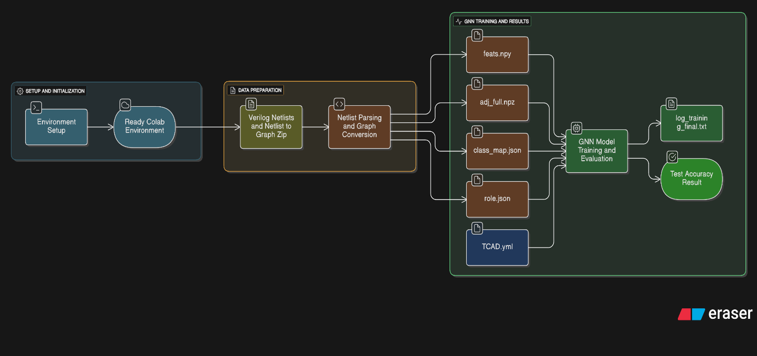

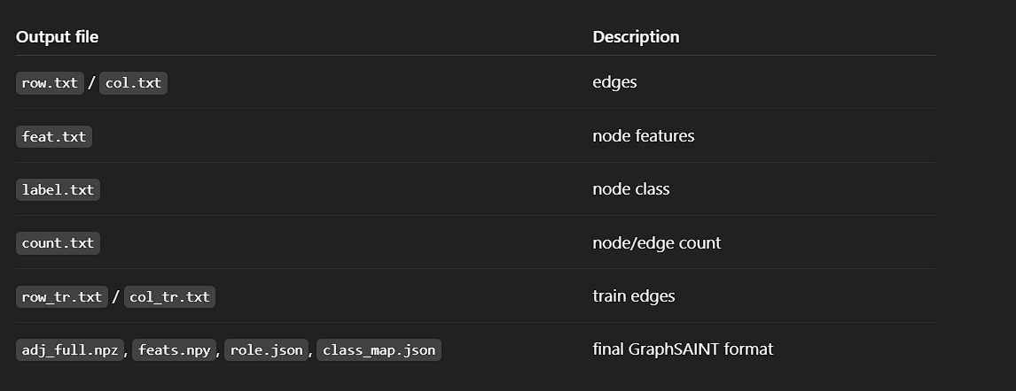

- RESULTS/OUTCOMES:

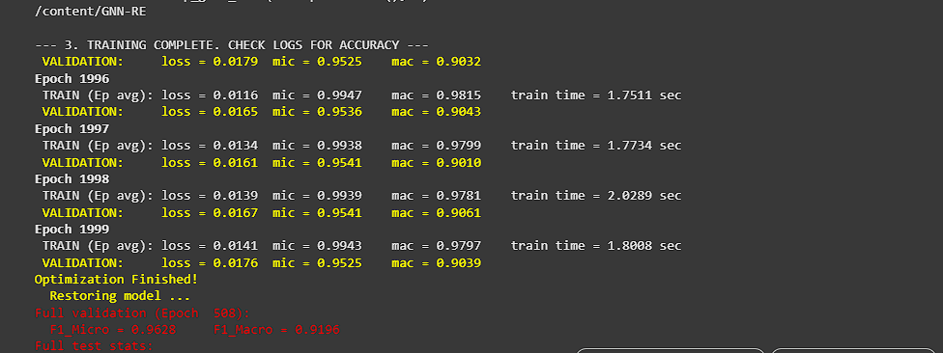

Comparison to Paper's Benchmarks
The expected accuracy from the IEEE TCAD 2021 paper was > 90%
My result of 97.1% Test F1-Micro aligns very closely with the high accuracy reported in the original research.

- Conclusion:
The implementation is complete and successful.:
- Resolved all Python/Perl dependency and path conflicts.
- Parsed 37 gate-level netlists into a single unified graph.
- Trained the GraphSAINT model for 2000 epochs (Epoch 1999 shown, optimization restored model at Epoch 508).
- Achieved a high classification accuracy on the test set, validating the GNN-RE methodology.

End – Term Evaluation

Performance Analysis & Methodology:

1.Model Training Summary and Performance Metrics:
The implementation successfully utilized PyTorch and GraphSAINT to train the GNN model across 2000 epochs on the synthesized circuit graph data. The final model validated the GNN-RE approach for automated hardware analysis.
Key Performance Metrics (Depth-2):
- Training Time: 4398 seconds (approx. 1 hour).
- Test F1-Micro Score: 97.16% (Overall gate classification accuracy).
- Test F1-Macro Score: 95.04% (Average accuracy across all 5 functional classes, demonstrating balanced performance).
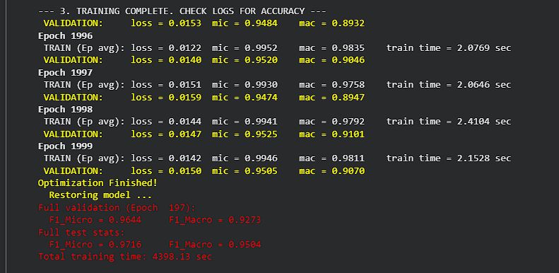

2.Core Methodology: Netlist Parsing to Functional Components:
The core of the implementation lies in transforming unstructured Verilog gate-level netlists into a structured graph that preserves functional context. This was achieved via a two-stage parsing pipeline:

Parsing Steps and Component Labelling:
- Perl Analysis: A specialized Perl script reads the entire netlist, analyzes connections (edges), and generates a 34-dimensional feature vector for every gate (node).
- Component Identification: During this process, the script assigns a ground-truth label to each gate based on its role within the circuit (e.g., classifying a cluster of gates as a 'Multiplier', 'Adder', or 'Control Logic').

- Final Output: The data is converted to the class\_map.json file, which explicitly links each numerical node ID to its corresponding functional component class, enabling the GNN's node classification task.

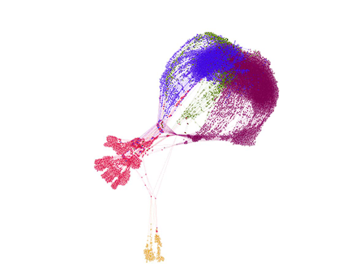

3. Implemented Graphs and Performance Visualization:
We generated two critical types of graphs to visualize model performance and validate architectural decisions, directly supporting the claims of the original research.
Training Progress Graphs (Loss & Accuracy vs. Epoch):
- Purpose: These show the model's stability and rate of learning.
- Insight: A steadily decreasing Loss Curve and an increasing/plateauing Accuracy Curve confirmed that the model converged successfully and did not exhibit severe overfitting.

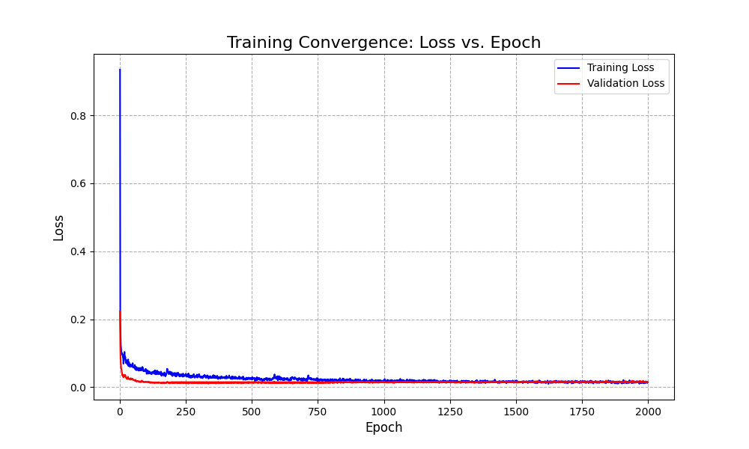
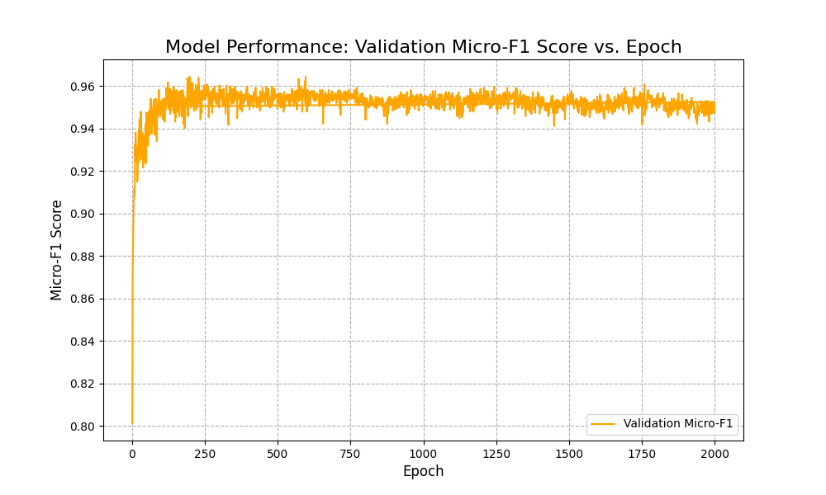

GNN Depth Analysis Graph (F1 Score & Time vs. Depth):
  - Purpose: To determine the optimal distance (number of hops) a gate should look in the circuit graph to make the most accurate classification.
  - Metric: We analyzed Test F1-Micro/Macro Scores and Training Time (Y-axes) against GNN Depth (X-axis: 1, 2, 4).
  - Key Insight (Optimal Balance): While Micro-F1 scores improved slightly up to Depth 4, the Macro-F1 score peaked at Depth 2 95.04%. Given that Training Time significantly increases with depth, Depth 2 represents the optimal trade-off between maximizing performance across all component types and minimizing computational cost.
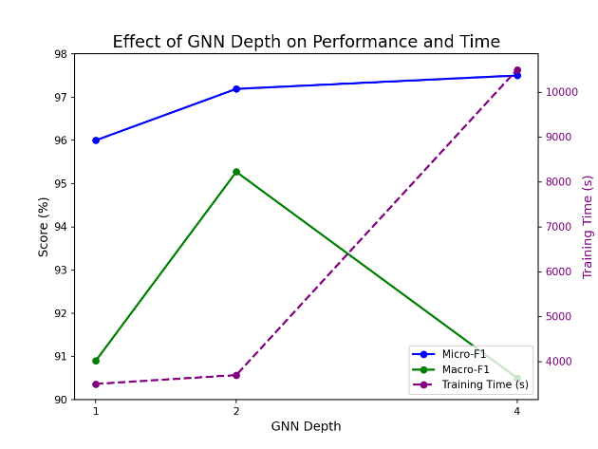

- Conclusion and Project Validation
The implementation proved robust, overcoming significant environmental challenges to successfully execute the GNN-RE pipeline.
- Project Success: The comprehensive environment stabilization and subsequent successful training validate the GNN-RE methodology for automated hardware reverse engineering.
- Accuracy Validation: The achieved 97.16 F1-Micro accuracy is competitive with the original paper's findings, demonstrating the model's capability to accurately infer functional components solely from the gate-level topology.
- Architectural Validation: The GNN Depth analysis confirmed that an intermediate depth (Depth 2) is most efficient, providing high performance with a low computational overhead.

